Secretory epithelium and glands
CHOOSE THE CORRECT ANSWER:

- What is the type of gland that secretes its products through a duct?
- Endocrine gland
- Multicellular gland
- Exocrine gland
- All of the above
- None of the above
- What is a gland called if the secretory portion is flask shaped?
- Simple gland
- Compound gland
- Tubular
- Alveolar
- Tubuloalveolar
- Goblet cells of intestinal epithelium are examples of :
a. unicellular glands
b. simple columnar epithelium
c. stratified epithelium
d. pseudostratified epithelium
e. none of the above
- Compound tubular gland is :
- Salivary gland
- Brunners gland
- Sweat gland
- All of the above
- None of the above
- Holocrine glands
- some cells are destroyed, to form the secretion
- no change occur in the secretory cells.
- the apex of the cell is destroyed during secretion
- sebaceous glands
- both a&d.
- Which of the following is a unicellular gland?
- Squamous cell
- Goblet cell
- Basal cell
- Basket cell
- Sertoli cell
7.Exocrine glands are defined as compound glands when the excretory ducts are :
- Branched .
- Unbranched .
- Draining mucous and serous acini d-both a&c
- both b&c
- tall
8.Sweat glands are an example of:
- Compound alveolar glands .
- Compound tubular glands .
- Simple coiled tubular glands .
- simple alveolar gland.
- compound tubuloalveolar .
9. Serous glands secrete:
- Watery secretion rich in enzymes .
- Viscid mucous .
- Oily secretion.
- mucoid secretion
- both c&d
10.One only of the following is an example of endocrine gland:
- Parotid gland
- Goblet cell
- Thyroid gland
- Sweat gland
- submandibular gland
11.Apocrine glands
- some cells are destroyed, to form the secretion
- sebaceous glands
- no change occur in the secretory cells
- salivary glands
- the apex of the cell is destroyed during secretion
12. In exocrine glands, ducts
- are not present
- open into the blood stream
- are branching
- are lined by different type of epithelium
- both c&d
Complete

13.A common feature of endocrine glands is their abundance of
14- An example of compound tubular gland are:
1. …………………………………… 2…………………………………….

15- Depending on the basis of chemical nature of their hormones, endocrine glands
1. …………………………………… 2…………………………………….
3…………………………………….. 4…………………………………….

True or false
16.Mammary gland is a classical example of merocrine glands
17.Sebaceous gland secretion occurs without cells break down
18.Sweat glands are simple coiled tubular glands.
Match
19.Endocrine cells of the ovary A. Compound saccular gland
20.Parotid gland B. steroid secreting cells
21.Sebaceous glands C. Compound acinar gland
22.Pancreas D. serous gland
E . simple branchedacinar glands

Mention :
23-Classification of glands.
...................................................................................................................................................................................................................................................................................................................................................................................................................................................................................................................................................................................................................

24-Classification of exocrine glands according to the number of cells
.........................................................................................................................................................................................................................................................................................................................................................................................................................................................................................................................................................................................................................................................................................................................................
25-Classification of exocrine glands according to the mode of secretion with examples.
..........................................................................................................................................................................................................................................................................................................................................................................................................................................................................................................................................................................................................................................................................................................................................

26-Classification of exocrine glands according to the nature of secretion with examples.
..........................................................................................................................................................................................................................................................................................................................................................................................................................................................................................................................................................................................................................................................................................................................................

27.Identify the cell and mention the structures pointed by the arrows in the following
diagrams;

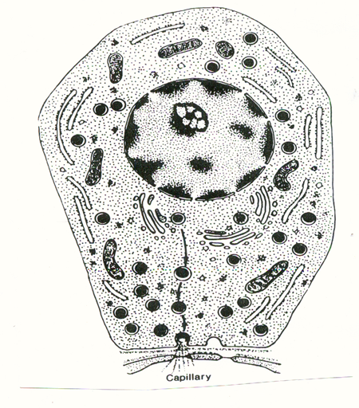
4
3
2
1

3
2
1

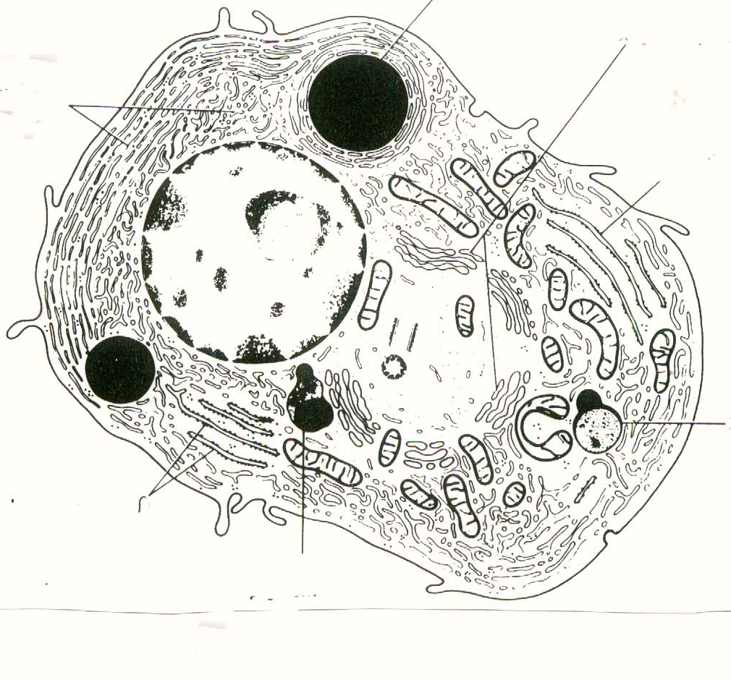
[اكتب اقتباساً من المستند أو من ملخص نقطة هامة. يمكنك وضع مربع النص في أي مكان في المستند. استخدم علامة التبويب "أدوات مربع النص" لتغيير تنسيق مربع نص الاقتباس.]
[اكتب اقتباساً من المستند أو من ملخص نقطة هامة. يمكنك وضع مربع النص في أي مكان في المستند. استخدم علامة التبويب "أدوات مربع النص" لتغيير تنسيق مربع نص الاقتباس.]
[اكتب اقتباساً من المستند أو من ملخص نقطة هامة. يمكنك وضع مربع النص في أي مكان في المستند. استخدم علامة التبويب "أدوات مربع النص" لتغيير تنسيق مربع نص الاقتباس.]
[اكتب اقتباساً من المستند أو من ملخص نقطة هامة. يمكنك وضع مربع النص في أي مكان في المستند. استخدم علامة التبويب "أدوات مربع النص" لتغيير تنسيق مربع نص الاقتباس.]
[اكتب اقتباساً من المستند أو من ملخص نقطة هامة. يمكنك وضع مربع النص في أي مكان في المستند. استخدم علامة التبويب "أدوات مربع النص" لتغيير تنسيق مربع نص الاقتباس.]
[اكتب اقتباساً من المستند أو من ملخص نقطة هامة. يمكنك وضع مربع النص في أي مكان في المستند. استخدم علامة التبويب "أدوات مربع النص" لتغيير تنسيق مربع نص الاقتباس.]
[اكتب اقتباساً من المستند أو من ملخص نقطة هامة. يمكنك وضع مربع النص في أي مكان في المستند. استخدم علامة التبويب "أدوات مربع النص" لتغيير تنسيق مربع نص الاقتباس.]

